Exercises: ASP.NET Essentials
Problems for exercises and homework for the “C# MVC Frameworks - ASP.NET” course @ SoftUni.

Car Dealer
You are provided with a ASP.NET MVC project with database model as follows.
A car dealer needs information about cars, their parts, parts suppliers, customers and sales.
- Cars have make, model, travelled distance in kilometers
- Parts have name, price and quantity
- Part supplier have name and info whether he uses imported parts
- Customer has name, date of birth and info whether he is young driver (Young driver is a driver that has less than 2 years of experience. Those customers get additional 5% off for the sale.)
- Sale has car, customer and discount percentage
A price of a car is formed by total price of its parts.
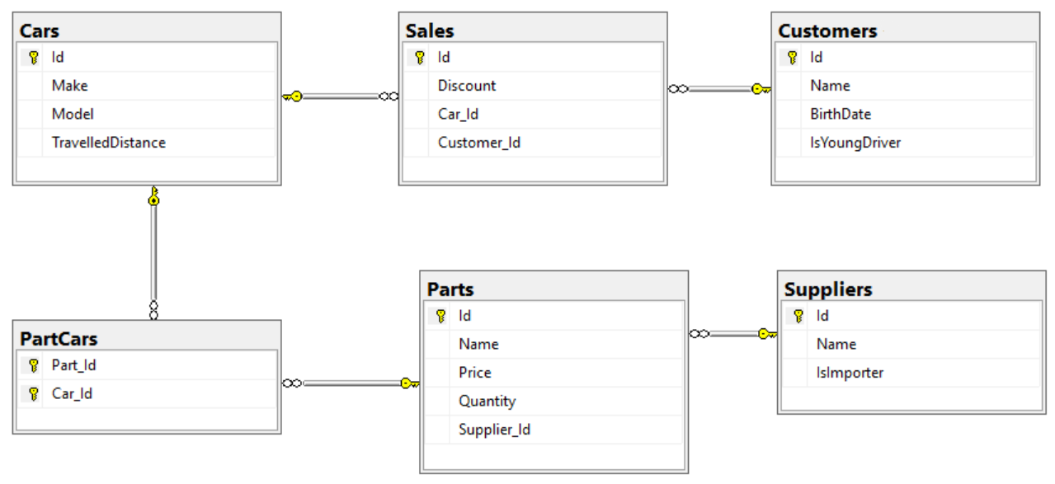
Relations between models:
- A car has many parts and one part can be placed in many cars
- One supplier can supply many parts and each part can be delivered by only one supplier
- In one sale, only one car can be sold
- Each sale has one customer and a customer can buy many cars

Car Dealer Import Data
Use the provided SQL script to populate the database with sample data.

Queries
Using the provided project skeleton create an application that can show to the user results from different queries described below. The results from the queries should be visualizes in a table.

Query 1 – Ordered Customers
Get all customers ordered by their birth date ascending or descending. If two customers are born on the same date first print those who are not young drivers (e.g. print experienced drivers first). Show their name, birthdate and whether he is young driver or not.

Example URLs
{host}/customers/all/ascending
{host}/customers/all/descending

Query 2 – Cars from make
Get all cars from make provided in the URL and order them by model alphabetically and by travelled distance descending. Show them in a table with their make, model and travelled distance.

Example URL
{host}/cars/{make}

Query 3 – Filter Suppliers
Get a list of all suppliers. There are two types of suppliers
- Local – do not import parts from abroad
- Importers – import parts from abroad
Get their id, name and the number of parts they can offer to supply.

Example URLs
{host}/suppliers/local
{host}/suppliers/importers

Query 4 – Cars with Their List of Parts {by id}
Get all cars along with their list of parts. For the car get only make, model and travelled distance and for the parts get only name and price.

Example URL
{host}/cars/{id}/parts

Query 5 – Total Sales by Customer
Get a customer by ID and show his name, bought cars count and total spent money on cars.

Example URL
{host}/customers/{id}

Query 6 – Sales with Applied Discount
Get all sales with information about the car (make, model, travelled distance), customer and price of the sale with and without discount and the discount percent itself.

Example URLs
{host}/Sales – list of all sales
{host}/Sales/{id} – more details about sale by provided Id (car make, car model, and customer name)
{host}/Sales/discounted – all sales that are discounted by any percentage
{host}/Sales/discounted/{percent} – all sales that are discounted with given percent

Hyperlinks
Add menu to the website with the following structure
- Customers – customers/all/ascending
- Sales
  - All – /sales
  - Discounted - sales/discounted
- Cars - cars/all list of all cars with their make, model and travelled distance

